TO DO

1. To figure out the situation at which the sensor reads full value (ie black)
2. To see the position at which the value of 512,1026 .. 1536 exist.
3. To see the variation of distance and study the relationship that exist between the values of 512 and 1024 of any other values.
4. To check weather the sensor reports all values between 1024 (sensor 2) and 1536 (sensor 3) because looking at the algorithm it appears that the values in between does not occur. So density variation of values exists. This leads to partial quantization

Conclusions

Studies

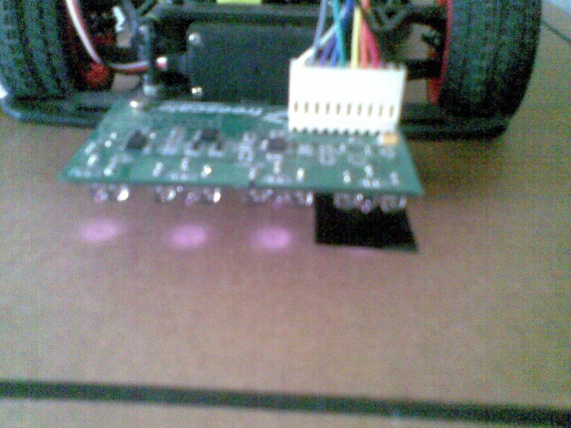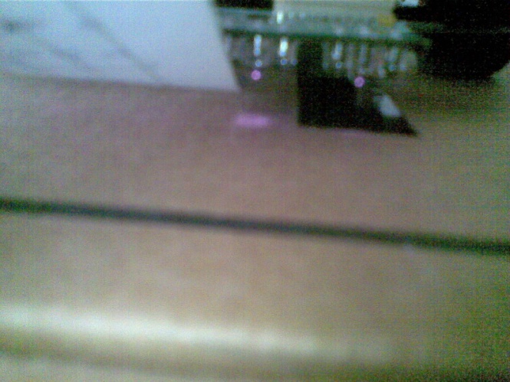

IR rays are visible.

The are not reflected by black

They do not penetrate the white paper.

Gursimran singh  
XLNC  
Thapar University, Patala